Position: Senior Manager/Team Manager (FML I)
Organization: L&T Finance
Function: Marketing & Campaign Analytics
Location: Mumbai – Santacruz (Kalina)

LTFS is one of the top NBFCs in India and its businesses are highly dependent on Analytics team for Insights, Acquisition, Collections and Lead Generation. For our esteemed Analytics team, we are seeking accomplished professionals with knowledge in modeling and analytics. Sound understanding of Financial Services and statistics.

As a Senior Manager/ Team Manager you will support L&T Finance in its goal of achieving growth by integrating analytics into end-to-end business solutions. By translating data-driven results into business-focused deliverables for decision makers, you would be a part of LTF’s journey as a high-performing Indian NBFC.

As a Data Scientist specializing in Marketing and Digital Analytics a you will play a crucial role in driving the development and execution of data-driven marketing campaigns that deliver personalized experiences to our users. You will collaborate closely with cross-functional teams including marketing and product development to leverage data insights and develop strategies that optimize customer engagement and drive business growth.

Summary of Responsibilities

- Digital Analytics:
  - Support a small/ medium team to analyse channel and touch point effectiveness, e.g. Google Ads, Google Tags, Email campaign, etc. using advanced analytics
  - Conduct analysis of livestream data, clickstream data, website traffic and campaign data to identify trends that can be used optimize marketing strategies
  - Analyse website and digital campaign performance data
  - Develop and implement machine learning models for user segmentation, content recommendation, and personalized messaging.

- Marketing Analytics:
  - Collaborate with marketing teams to tailor customized campaign strategies to specific customer segments and individual preferences.
  - Leverage data insights to optimize campaign targeting, messaging, and creative elements for maximum impact and relevance on
  - Develop KPIs and performance metrics to measure effectiveness of marketing campaign. Using data, identify scope to increase ROI in marketing campaign
  - Implement A/B testing methodologies to evaluate the effectiveness of different campaign approaches and iterate on strategies based on performance outcomes.

- Campaign Analytics:
- Collaborate with cross-functional teams and come up with campaign ideas to drive different business objectives

- Oversee ongoing campaign process; make strategic analytics-related decisions during planning process (data capture and tracking),
- Develop real-time optimization during campaigns, and report post-campaign with a focus on takeaways and recommendations to optimize future campaigns

- Predictive Modelling:
- Utilize statistical methods and machine learning algorithms to best target the customers through campaign and derive insightful analysis
- Design, develop and implement of predictive models for marketing and campaign activities

- Technology Integration and Innovation:
  - Work closely with the product development team to integrate advanced personalization capabilities into the Planet App platform.
  - Stay informed about emerging technologies and industry best practices in hyper-personalization to drive continuous innovation and improvement.
  - Act as a subject matter expert on marketing analytics tools and technologies, providing guidance and support to internal stakeholders as needed.

- Reporting and Communication:
  - Prepare and present regular reports on campaign performance, including key metrics, insights, and recommendations for optimization.
  - Communicate findings and insights effectively to stakeholders across the organization, translating complex data concepts into actionable recommendations.
  - Collaborate with cross-functional teams to ensure alignment and transparency in marketing initiatives and performance goals.

Desired Skills and Experience
- Masters in Statistics, Data Science, or related field/ MBA in Marketing with proven experience in Marketing & Campaign analytics/ automation

- Experience in leading team

- Hands-on recent experience with Clever Tap, MoEngage, Adobe Analytics (Omniture SiteCatalyst), Adobe Audience Manager, or similar web analytics, web optimization, Google Analytics, Digital Analytics will be required

- Strong analytical background with expertise in machine learning

- Familiarity with marketing automation platforms and CRM systems. (Mo-Engage, Clever Tap, Salesforce).

- Familiarity with digital data aggregation from Facebook, Instagram, Youtube campaigns

- Strong proficiency in data analysis tools and programming languages such as SQL, Python.

- Excellent communication and presentation skills, with the ability to distill complex data concepts into clear and actionable insights.

- Self-started with a strong work ethic, result-oriented and highly accountable with an entrepreneurial predisposition

- Ability to work collaboratively in cross-functional teams and adapt to evolving priorities and business needs.

- Experience in Google Cloud Platform/ Google BigQuery/Vertex AI are a huge advantage.

- Experience in BFSI domain, Indian Banks and NBFCs is a huge advantage.

Why Work with L&T Finance

Work for Bharat & INDIA: LTF is present in both Rural and Urban areas with products catering to remote villages and also urban cities, you will get to solve the real-world problem of both India & Bharat which will impact and change the lives of millions of customers. The candidate will not only touch the lives of extremely Rural India but will also have opportunity to shape the financial future of Gen Z.

Work on Cutting Edge Tools/Techniques: We are sitting on verge of tech transformation and you will be using R/Python/Google Vertex AI & No/Low code Cloud analytics tool to perform Predictive and Prescriptive Modeling using AI techniques, Machine Learning techniques, Computer Vision, NLP, Text Analytics, Customer Segmentation, Time series analysis to work on areas like Risk Analytics, Fraud Analytics, Credit Analytics, Marketing Analytics etc…

Industry Awards: Despite multiple Analytics awards, L&T Finance has been awarded with renowned “Best Firm for Data Scientists 2023” Award by Analytics India Magazine. This underlines the culture, technology hunger and impact of Analytics on Organizational growth.

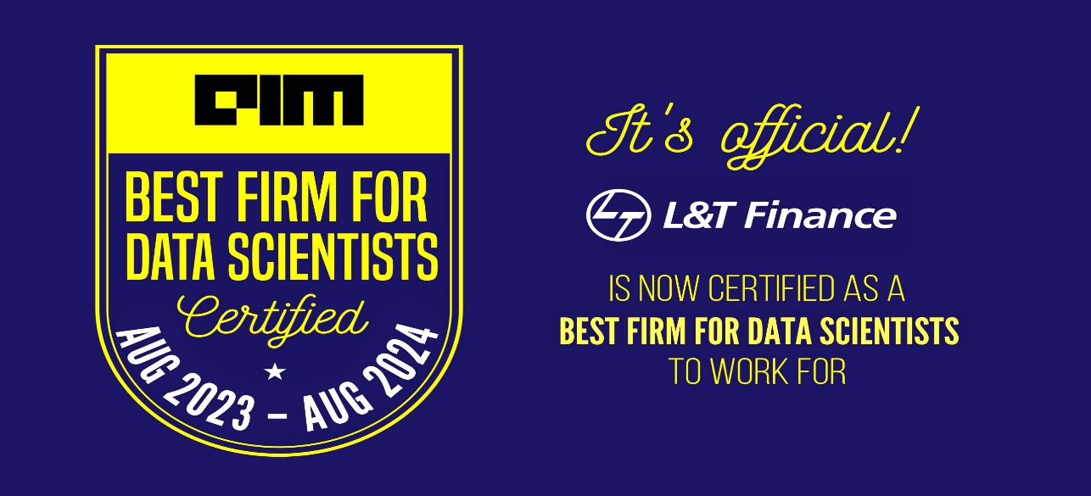

Collaborative & Learning Environment: You will get to work in collaborative and learning focused working environment where you will get the exposure to directly work with business leaders

